LECTURE 1
INTRODUCTION

Some Formal Definitions of Blockchain
Blockchain is a technology used to store records (data) in a secure, shared, and distributed way.
Easy explanation:
- Blockchain is like a digital record book (ledger).
- This record book is not stored in one place.
- Instead, many computers around the world keep the same copy.
- Once something is written, it is very hard to change.
Key points to remember:
- It is cryptographically secure → data is protected using encryption.
- It is shared → everyone in the network can see the records.
- It is distributed → no single computer or authority controls it.
- Used for sensitive data like:
  - Financial transactions
  - Voting records
  - Ownership records
Simple example:
Instead of one bank keeping all transaction records, thousands of computers keep the same record.
If someone tries to change it, everyone else will notice.

Why Bother?
This basically means: Why do we even need blockchain?
The main reason:
To build trust in digital systems
Problems in traditional systems:
- One central authority controls data
- Data can be:
  - Changed
  - Hidden
  - Hacked
- Users must trust a middleman (bank, company, government)
How blockchain helps:
- No single person controls the system
- Everyone can see and verify transactions
- Data cannot be changed without network agreement (consensus)
Key benefits:
- Transparency → everyone can see what’s happening
- Trust → no need to blindly trust one authority
- Accountability → actions are recorded permanently
Simple example:
In online payments, you trust the bank.
In blockchain, you trust the system itself, not a company.

How Exactly Does the Blockchain Work?
- A blockchain is a chain of blocks
- Each block contains:
  - Data (transactions)
  - Its own hash (digital fingerprint)
  - Hash of the previous block
- Because each block stores the previous block’s hash, all blocks are linked together
- If someone changes one block, all following hashes change, so tampering is detected
This is what makes blockchain secure and tamper-resistant
Structure of a Block
Each block has:
- Data
  - Transaction details (sender, receiver, amount, etc.)
- Hash
  - A unique fixed-length code created from the block’s data
- Previous Hash
  - Hash of the block before it
First block is called the Genesis Block
- Its previous hash is usually 0000
How Blockchain Works (Step-by-Step Process)
Step 1: A Transaction Is Requested
- A user requests a transaction
- Example:
  - Sending money
  - Buying crypto
  - Recording data (vote, record, asset)
Step 2: A Block Is Created
- The transaction details are grouped into a block
- The block contains:
  - Transaction data
  - Hash
  - Previous block’s hash
Step 3: Block Is Sent to the Network
- The block is sent to all nodes (computers) in the blockchain network
- These nodes are non-trusted peers
- No central authority exists
Step 4: Nodes Validate the Transaction
- Nodes verify the transaction by checking:
  - Is the sender valid?
  - Is there enough balance?
  - Is the transaction following rules?
- This process is called validation
Step 5: Proof of Work & Reward
- Nodes (miners) solve complex mathematical problems
- This process is called Proof of Work
- The first node to solve it:
  - Confirms the block
  - Gets a reward (e.g., Bitcoin)
Proof of Work prevents fake transactions
Step 6: Block Is Added to the Blockchain
- After validation:
  - Block is added to the existing chain
  - It is linked using hashes
- The ledger is updated on all nodes
Step 7: Transaction Is Completed
- The transaction becomes:
  - Permanent
  - Secure
  - Nearly impossible to change
- Everyone in the network has the same updated copy
Why This System Is Secure
- Blocks are linked using hashes
- Data is stored on many computers
- Any change in one block breaks the chain
- Requires network consensus to modify data

Financial Systems
A financial system is a way through which money or value is exchanged between people.
1. Traditional Financial Systems
These are the old and basic ways of exchanging value.
a) Barter Trade
- Goods are exchanged directly for other goods
- No money involved
Example:
A farmer gives wheat to a carpenter in exchange for a table.
Problems:
- Both people must want what the other has
- No fixed value for goods
b) Coins
- Metal money used as a medium of exchange
- Easier than barter
Example:
Gold, silver, or copper coins used in ancient times.
Improvement over barter:
- Standard value
- Easier to carry and store
c) Currency Notes
- Paper money issued by governments
- Widely accepted
Example:
Rupees, Dollars, Pounds.
Benefits:
- Easy to use
- Standard value
- Portable
2. Online Payment Systems
These systems use banks and technology to transfer money electronically.
a) Bank Transfers
- Money is transferred from one bank account to another
- Requires banks as intermediaries
Example:
Online bank transfer, wire transfer.
Limitations:
- Can be slow
- Charges may apply
- Depends on bank working hours
b) Credit Cards
- Allow users to pay now and pay later
- Issued by banks or financial institutions
Example:
Visa, MasterCard.
Issues:
- Transaction fees
- Risk of fraud
- Requires trust in the bank
3. Digital Currencies
Digital form of money used electronically.
Cryptocurrencies
- Digital currencies based on blockchain technology
- Not controlled by banks or governments
- Decentralized
Example:
Bitcoin, Ethereum.
Key features:
- Peer-to-peer transactions
- High transparency
- Secure using cryptography

Advantages
1. Greater Transparency
What it means:
- All participants in a blockchain network share the same data
- Everyone sees the same version of records
How blockchain provides transparency:
- Blockchain is a distributed ledger
- Records are updated only after network consensus
- Once data is added, it cannot be secretly changed
Why this is important:
- No hidden changes
- No fake records
- Builds trust between users
Example:
In a supply chain, all parties (supplier, manufacturer, retailer) can see where a product came from and where it goes.
2. Enhanced Security
What it means:
- Blockchain protects data from hacking and tampering
How blockchain improves security:
- Transactions must be verified before being recorded
- Data is protected using cryptography (encryption)
- Each block is linked to the previous one using hashes
- Data is stored on many computers, not one server
Why this is important:
- No single point of failure
- Very difficult for hackers to change data
Example:
To change one transaction, a hacker would need to change all following blocks on most computers, which is almost impossible.
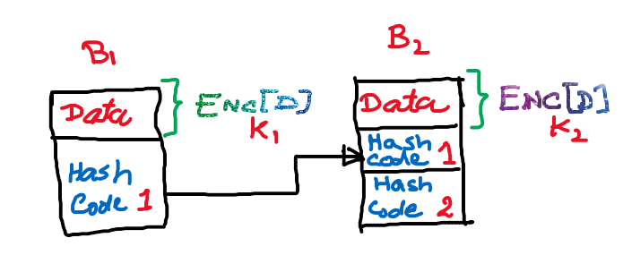
Block Linking, Hashing, and Encryption in Blockchain
This diagram explains how blocks are connected securely in a blockchain using hash codes and encryption.
Block B1 (First Block)
- Data:
Contains the transaction or information stored in the block.
- Encryption (Enc[D], K₁):
The data is encrypted using a key K₁ to keep it confidential.
- Hash Code 1:
A cryptographic hash is generated from the encrypted data.
This hash uniquely represents the contents of Block B1.
Block B1 does not store a previous hash because it is the first block.
Block B2 (Next Block)
- Data:
Contains new transaction or process information.
- Encryption (Enc[D], K₂):
The data is encrypted using a different key (K₂).
- Hash Code 1 (Previous Hash):
Stores the hash of Block B1.
This creates a link between B1 and B2.
- Hash Code 2:
Hash generated from Block B2’s own encrypted data.
How the Linking Works
- Block B2 stores Hash Code 1, which belongs to Block B1.
- If the data in Block B1 is changed:
  - Hash Code 1 changes
  - Block B2 no longer matches
  - The blockchain becomes invalid
This ensures data integrity and tamper detection.
Role of Encryption and Hashing
- Encryption:
  - Protects data privacy
  - Only authorized users can read the data
- Hashing:
  - Ensures data integrity
  - Detects any modification in blocks

3. Improved Traceability
What it means:
- Ability to track the history of an asset or transaction
How blockchain helps in traceability:
- Every transaction is time-stamped and recorded
- All records are stored in order
- Full history is always available
Why this is important:
- Easy to find the source of goods
- Helps prevent fraud and fake products
Example:
In food supply chains, blockchain can show:
- Where food was grown
- How it was transported
- When it reached the store
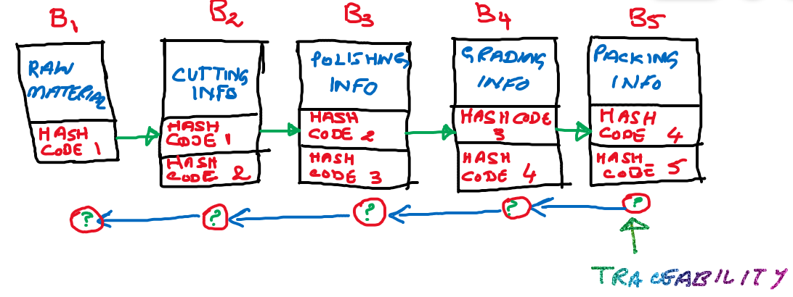
Block-wise Explanation (Traceability Example)
In blockchain, data is stored in blocks that are linked together using cryptographic hash codes. Each block represents a specific stage in a process. This linkage allows full traceability of information.
Block B1 – Raw Material
- Stores information about the raw materials used.
- Generates its own unique Hash Code 1.
- Acts as the starting point of the blockchain.
Block B2 – Cutting Information
- Stores details of the cutting process.
- Contains:
  - Hash Code 1 (from Block B1)
  - Its own Hash Code 2
- This links the cutting stage to the raw material stage.
Block B3 – Polishing Information
- Stores information about the polishing process.
- Contains:
  - Hash Code 2 (from Block B2)
  - Its own Hash Code 3
- Ensures continuity of data from cutting to polishing.
Block B4 – Grading Information
- Stores quality checking and grading details.
- Contains:
  - Hash Code 3 (from Block B3)
  - Its own Hash Code 4
- Helps verify product quality at this stage.
Block B5 – Packing Information
- Stores packing and final product details.
- Contains:
  - Hash Code 4 (from Block B4)
  - Its own Hash Code 5
- This is the final block in the blockchain.
4. Increased Efficiency and Speed
What it means:
- Transactions are completed faster with less manual work
How blockchain improves efficiency:
- Removes paperwork
- No need for repeated record checking
- Transactions are automated using blockchain rules
- Everyone uses the same shared ledger, so no reconciliation is needed
Why this is important:
- Saves time
- Reduces human errors
- Faster processing compared to traditional systems
Example:
International money transfer:
- Bank system → takes days
- Blockchain → takes minutes
5. Reduced Costs
What it means:
- Blockchain lowers transaction and operational costs
How blockchain reduces costs:
- No need for middlemen (banks, brokers)
- Less paperwork and manual verification
- Lower auditing costs
- No central infrastructure to maintain
Why this is important:
- Cheaper transactions
- Lower service fees for users and companies
Example:
Sending money without paying bank or transfer fees using blockchain.
6. Decentralized Control
What it means:
- No single authority controls the system
How decentralization works:
- Data is shared across many nodes
- Decisions are made using consensus
- Every participant follows the same rules
Why this is important:
- No single point of control or failure
- Fair and open system
- Less risk of corruption or misuse of power
Example:
Cryptocurrencies are not controlled by any government or bank.

Disadvantages
1. 51% Attack
What it means:
- Blockchain decisions are made by majority consensus.
- If one entity controls more than 50% of the network’s computing power, it can manipulate the blockchain.
What can happen:
- Fake transactions can be approved
- Transactions can be reversed
- Trust in the blockchain is reduced
Important point:
- This attack is theoretically possible but very difficult in large networks because it requires huge computational power.
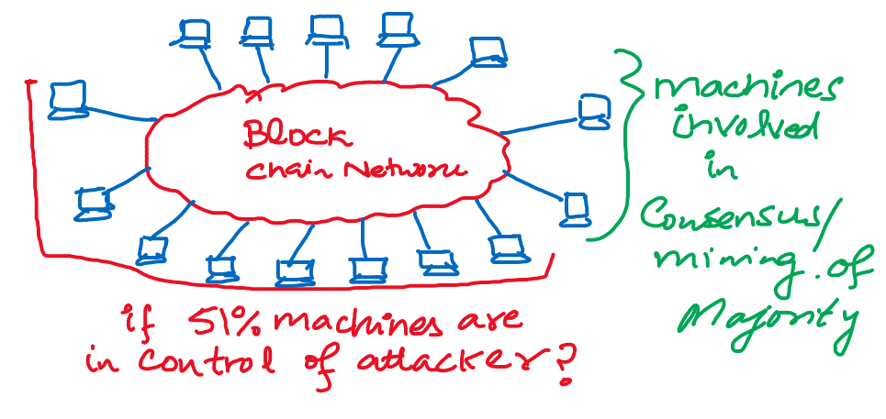
This diagram shows a 51% attack in a blockchain network.
It illustrates that when most of the machines (nodes) in the blockchain network participate in consensus/mining, the system follows the majority decision.
If 51% or more machines are controlled by an attacker, the attacker can control the network, manipulate transactions, and break the trust of the blockchain.
2. Data Modification
What it means:
- Once data is added to a blockchain, it is very hard to change or delete.
Why this is a disadvantage:
- If incorrect data is stored, fixing it is difficult
- Modifying data requires:
  - Changing the block
  - Recreating all following blocks
  - Gaining network consensus
Result:
- Blockchain is not suitable where data needs frequent correction.
3. Private Keys
What it means:
- Blockchain uses public and private keys for ownership and access.
Why this is a problem:
- The private key must be kept secret
- If a user loses their private key:
  - They lose access to their data or cryptocurrency
  - There is no recovery mechanism
Result:
- Users are fully responsible for their keys
- Loss of key means permanent loss
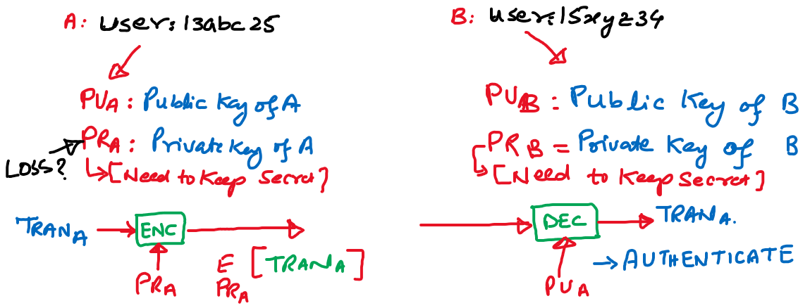
The diagram shows how a blockchain transaction is authenticated using public-key cryptography. User A wants to perform a transaction, such as sending digital assets or recording data on the blockchain. To prove that this transaction genuinely comes from them, User A uses their private key. The private key is secret and known only to User A, so anything created using it proves A’s identity.
User A creates the transaction data and then signs the transaction with their private key. This signing process generates a digital signature that is attached to the transaction. The transaction data itself is not hidden or encrypted; it remains visible. The purpose of the signature is not secrecy, but authentication and integrity—it proves who created the transaction and ensures the data has not been altered.
The signed transaction is then sent across the network. User B (or any other network node) receives this transaction and needs to verify whether it is valid. To do this, User B uses User A’s public key, which is freely available. Using this public key, B verifies the digital signature attached to the transaction. If verification succeeds, it confirms that the transaction was truly created by User A and that the data has not been changed.
Even though the public key is known to everyone, security is not compromised. The public key can only verify a signature—it cannot create one. Without access to User A’s private key, no attacker can generate a valid transaction pretending to be User A. This is why private keys must be protected and why losing them means losing control over blockchain assets.
In summary, the diagram illustrates that private keys are used to sign transactions, public keys are used to verify them, and this mechanism allows blockchains to securely confirm ownership and authenticity without relying on a central authority.
4. Storage
What it means:
- Blockchain stores a copy of the ledger on every node in the network.
Why this is a disadvantage:
- As more transactions are added, the blockchain keeps growing in size.
- Nodes must store the entire blockchain history.
- Over time, this requires very large storage space.
Result:
- Devices with limited storage cannot act as full nodes.
- Some nodes may drop out of the network due to storage limitations.
5. Power Wastage
What it means:
- Some blockchains (like Bitcoin) use Proof of Work, which requires heavy computation.
Why this is a disadvantage:
- Mining consumes a huge amount of electrical energy.
- Large numbers of machines run continuously to solve complex problems.
Result:
- High energy costs
- Environmental concerns
- Expensive transactions due to energy usage

